PHASE 7 – PROJECT DOCUMENTATION
Project Title
Import Data using Transform Maps (Spreadsheet)
1. Introduction
Project Documentation is the process of preparing and organizing all the important information related to the project. It explains the project purpose, requirements, design, development process, testing results, and final output.
The project “Import Data using Transform Maps (Spreadsheet)” documents the complete process of importing employee information from a spreadsheet into ServiceNow using Import Sets and Transform Maps.

2. Project Description
The project demonstrates how structured employee data from an external spreadsheet can be imported into ServiceNow.
The spreadsheet data is first loaded into the Employee Import Import Set table. A Sample Spreadsheet Import Transform Map is then used to map the source fields to the Employee Test target table.
The Employee ID field is configured as a Coalesce field so that existing employee records can be identified during subsequent imports.
The project also includes employee reports and an Employee Analytics Dashboards dashboard for viewing the imported information.

3. Project Objectives
The main objectives of the project are:
- To import employee data from a spreadsheet into ServiceNow.
- To create the Employee Test target table.
- To create the Employee Import Import Set table.
- To create the Sample Spreadsheet Import Transform Map.
- To map source fields to target fields.
- To configure Employee ID as a Coalesce field.
- To update existing employee records.
- To insert new employee records.
- To validate the transformed employee data.
- To create employee reports.
- To create the Employee Analytics Dashboards dashboard.

4. Technologies and Tools Used
Technology/Tool | Purpose
ServiceNow | Main development platform
Spreadsheet | Source of employee data
Import Sets | Temporary staging of imported data
Transform Maps | Transformation and field mapping
Employee Import | Import Set table
Employee Test | Target table
ServiceNow Reports | Data analysis and visualization
Employee Analytics Dashboards | Centralized dashboard

5. Project Workflow
The complete project workflow is:
Employee Spreadsheet
↓
Employee Import
↓
Sample Spreadsheet Import Transform Map
↓
Field Mapping
↓
Employee ID Coalesce
↓
Employee Test
↓
Reports
↓
Employee Analytics Dashboards

6. Table and Field Documentation
6.1 Employee Import Table
The Employee Import table is used as the Import Set staging table for the spreadsheet data.
The employee information contains the following fields:
Field
Employee ID
Employee Name
Email
Department
Location

6.2 Employee Test Table
The Employee Test table is the target table where the transformed employee records are stored.
Field
Employee ID
Employee Name
Email
Department
Location

Figure 1: Employee Test Table
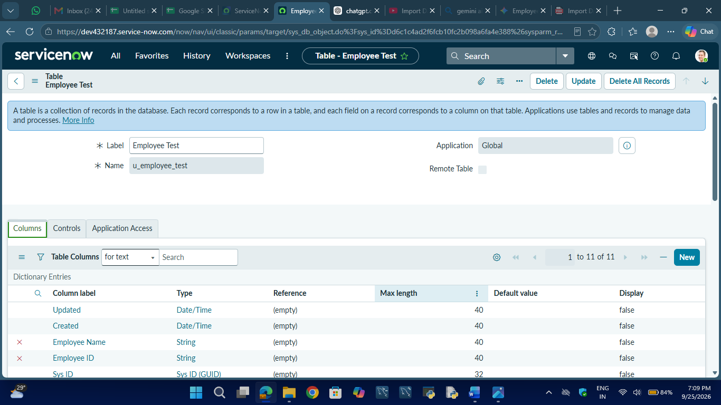

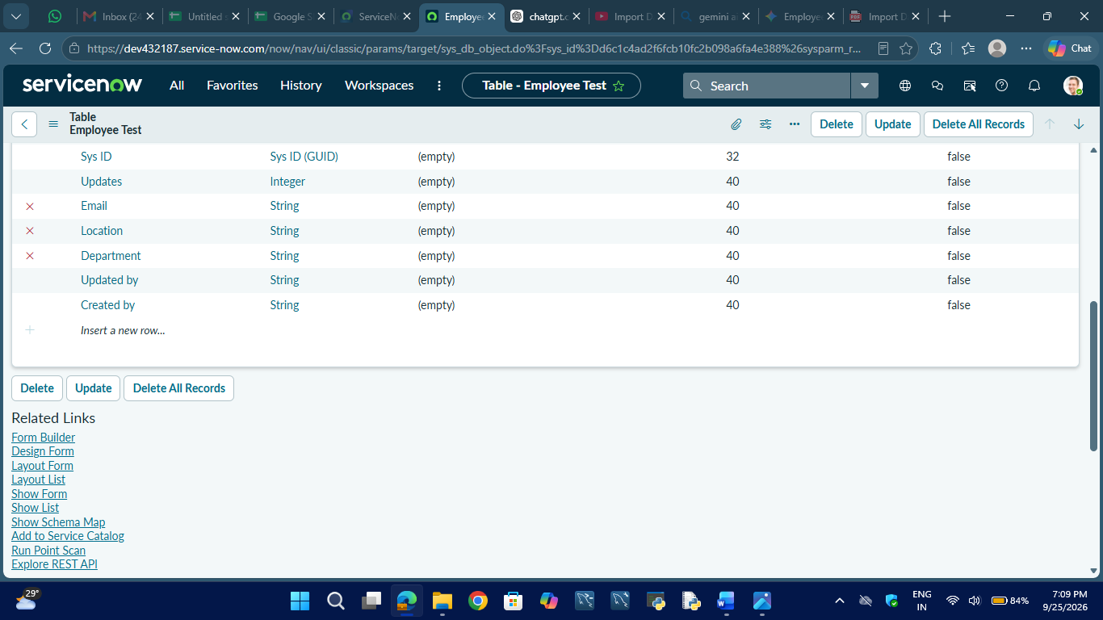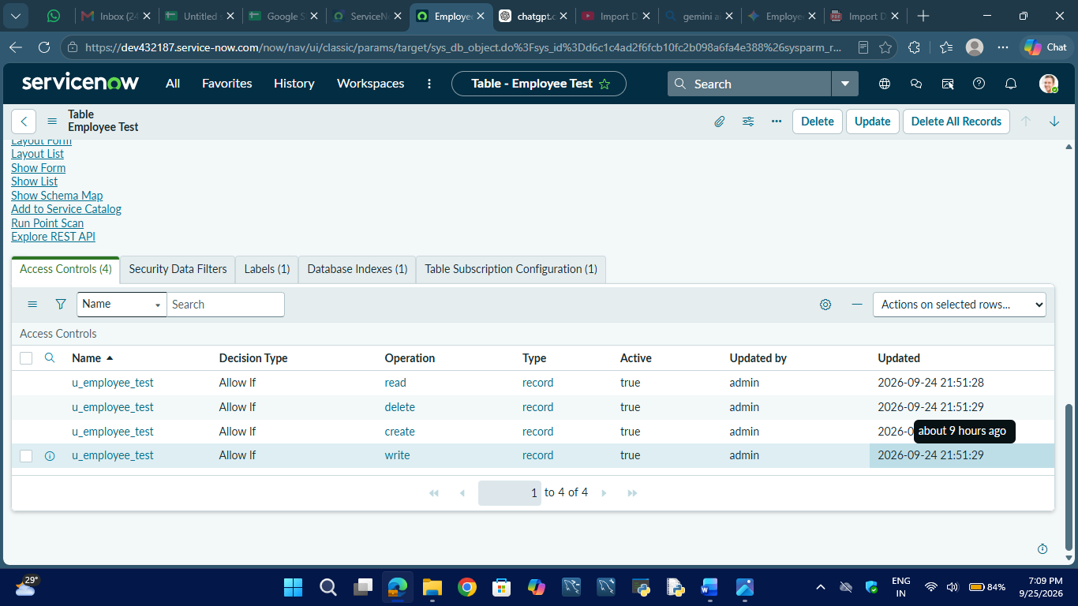

7. Transform Map Documentation
The Transform Map used in the project is:
Transform Map Name: Sample Spreadsheet Import
Source Table: Employee Import
Target Table: Employee Test
The Transform Map connects the source employee data with the corresponding fields in the target table.
Field Mapping
Source Field | Target Field
Employee ID | Employee ID
Employee Name | Employee Name
Email | Email
Department | Department
Location | Location
Figure 2: Transform Map
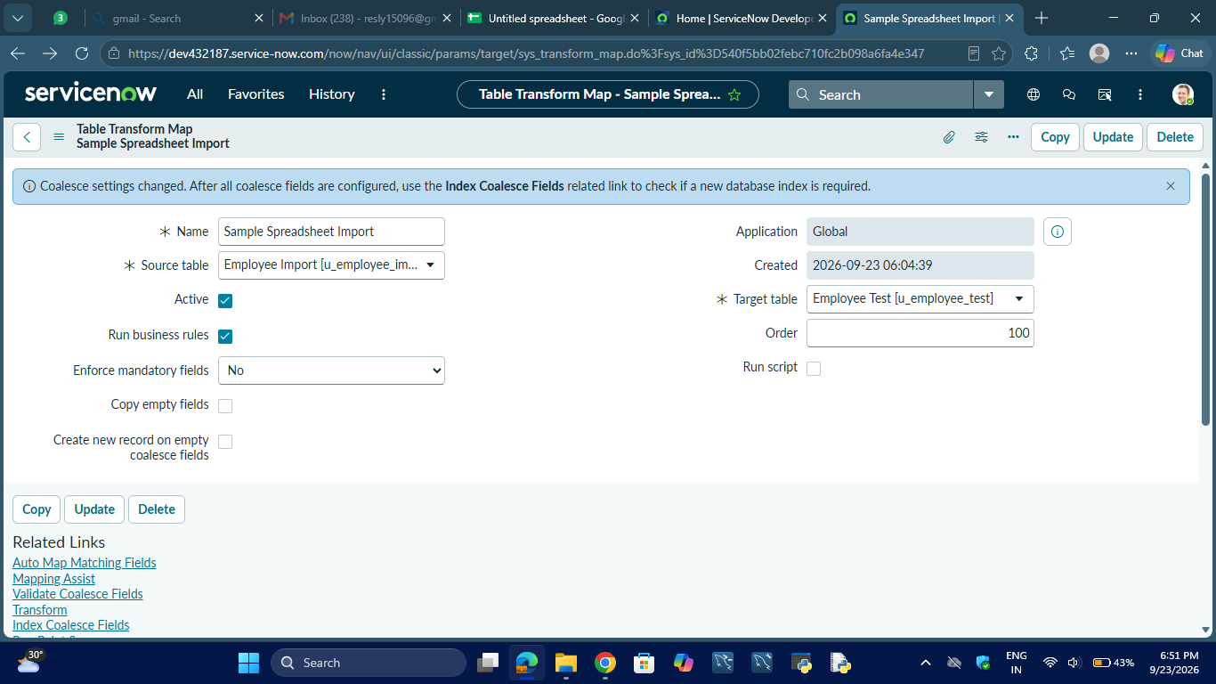

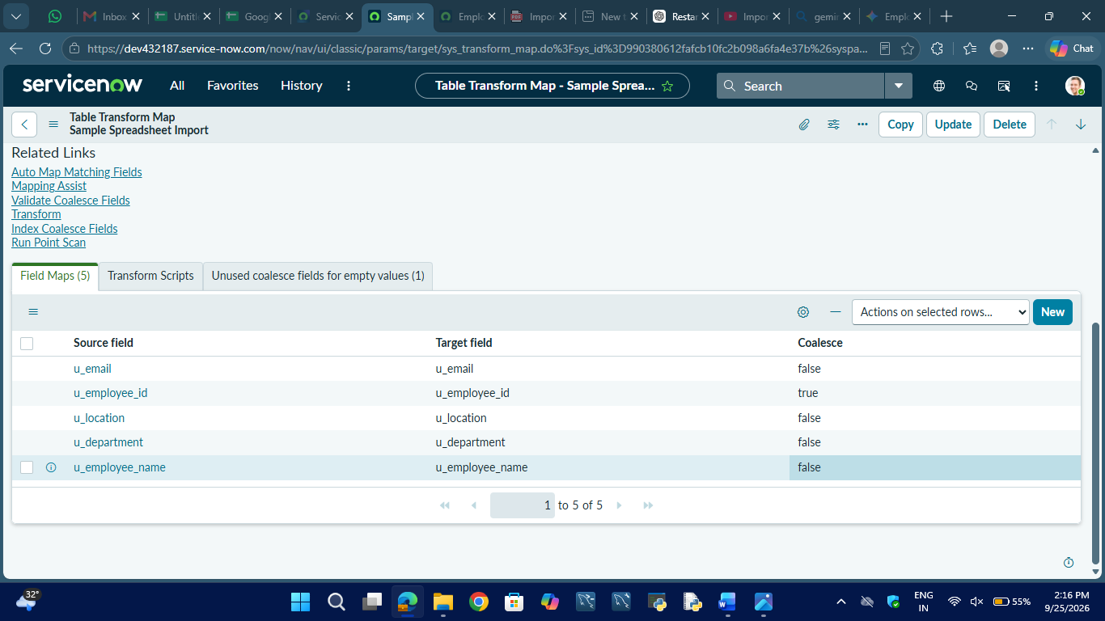

8. Coalesce Documentation
The Employee ID field is configured as the Coalesce field.
Source Field: Employee ID
Target Field: Employee ID
Coalesce: True
The Coalesce configuration is used to identify existing employee records during data transformation. This allows the system to update an existing record when the Employee ID already exists and insert a new record when the Employee ID is new.

9. Reports Documentation
The project contains the following employee reports:
9.1 Employees by Department
- Source Table: Employee Test
- Report Type: Pie Chart
- Group By: Department
- Aggregation: Count
This report provides a department-wise view of employee records.
9.2 Employees by Location
- Source Table: Employee Test
- Report Type: Bar Chart
- Group By: Location
- Aggregation: Count
This report provides a location-wise view of employee records.
9.3 Employee List Report
The Employee List Report displays:
- Employee ID
- Employee Name
- Email
- Department
- Location

Figure 4: Employee List Report
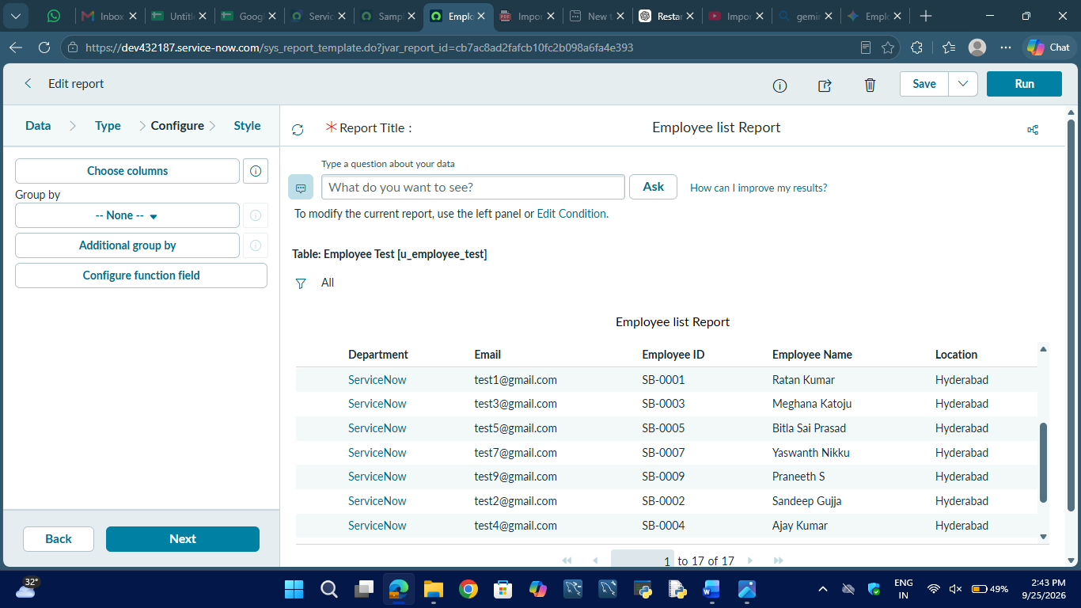

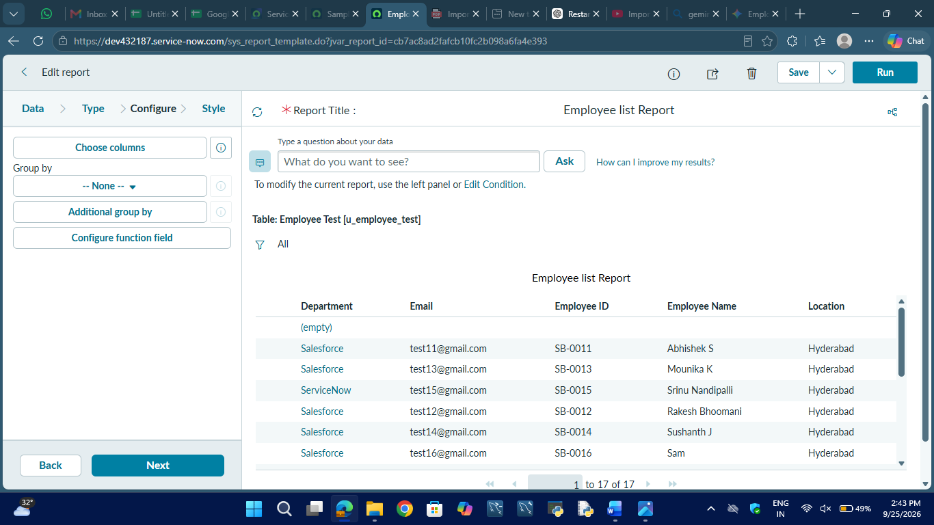

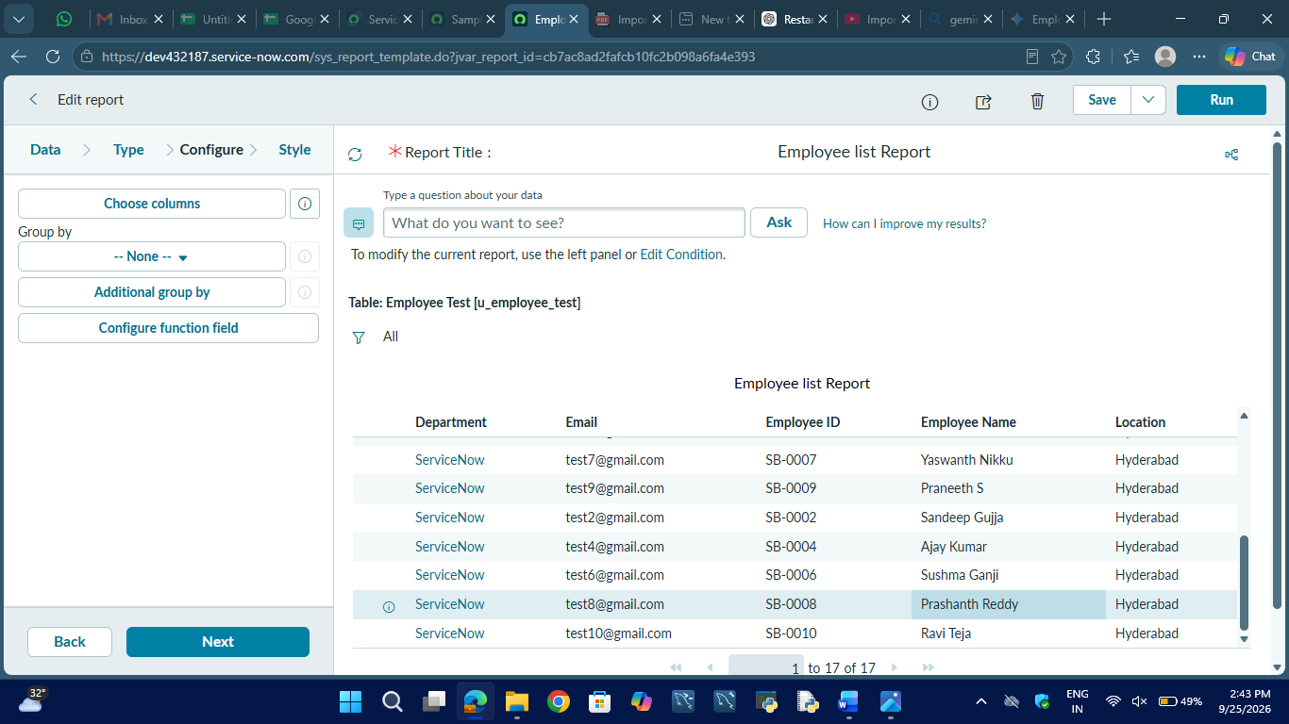

10. Dashboard Documentation
The project includes the dashboard:
Employee Analytics Dashboards
The dashboard contains the following employee analytics components:
- Employees by Department
- Employees by Location
- Employee List
The dashboard provides a centralized view of the employee information imported into ServiceNow.

Figure 5: Employee Analytics Dashboards
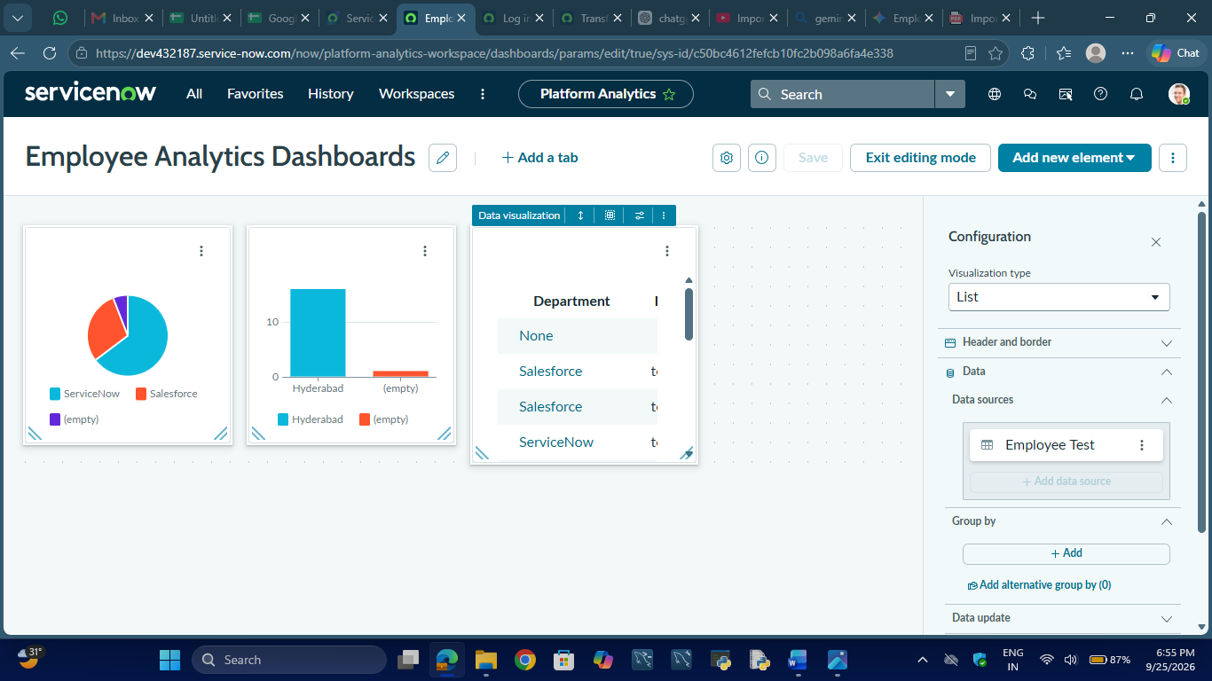

11. Testing Documentation
The project was tested to verify:
- Employee Import table
- Employee Test table
- Transform Map
- Field mappings
- Employee ID Coalesce
- Data transformation
- Employee records
- Update and insert functionality
- Employees by Department report
- Employees by Location report
- Employee List Report
- Employee Analytics Dashboard
The testing results are documented in Phase 6 – Project Testing.

12. Final Project Output
The final project provides a complete spreadsheet-to-ServiceNow employee data import process.
The final output includes:
- Imported employee records
- Employee Test target table
- Transform Map
- Coalesce configuration
- Employee reports
- Employee Analytics Dashboard
Figure 3: Employee Records
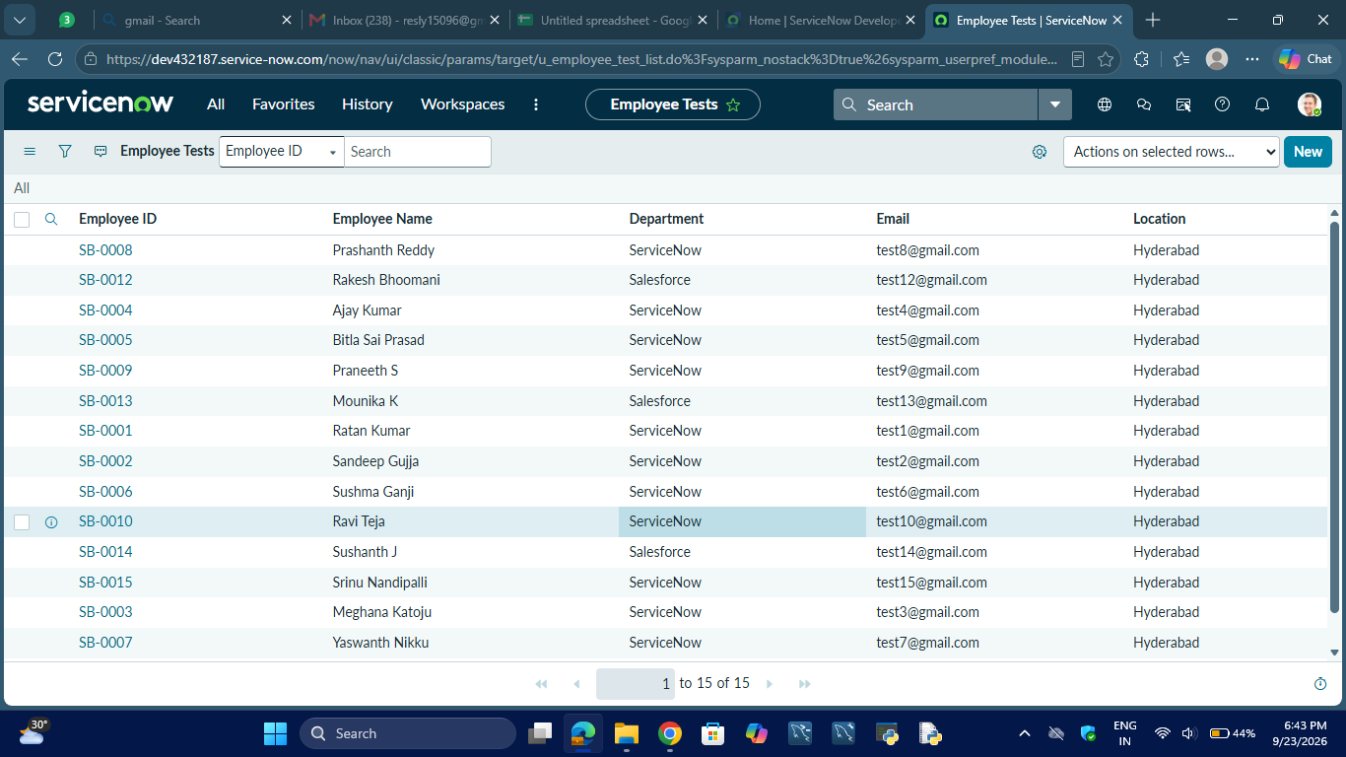

13. Documentation Summary
The project documentation describes the complete implementation of Import Data using Transform Maps (Spreadsheet). It covers the project workflow, tables, fields, Transform Map, field mapping, Coalesce configuration, reports, dashboard, testing, and final output.

14. Conclusion
The project documentation provides a structured record of the ServiceNow employee data import solution. It explains how spreadsheet data is loaded into an Import Set, transformed using a Transform Map, mapped into the Employee Test table, and analyzed through reports and the Employee Analytics Dashboards dashboard.

